Marks Secured: 8
Insights and Comments missing
Freq Poly, change the bin width

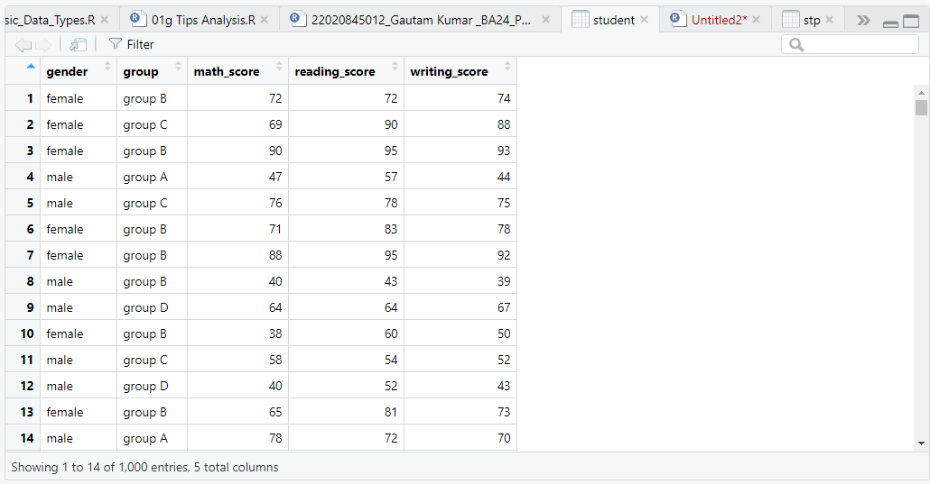

install.packages("readxl")
install.packages("tidyverse")
install.packages("ggplot2")
install.packages("cowplot")
install.packages("tidyverse")

library(readxl)
library(dplyr)
library(ggplot2)
library(tidyverse)

student = read_excel("C:/Users/gauta/Desktop/dataset/StudentsPerformance.xlsx")
view(student)
summary(student)
nrow(student)
str(student)
tail(student)
head(student)
colors = seq(612,656,by=3)

student$group
student$gender

#Total no of students(female and male)
table(student$gender)

#To find total no. of students in a group.
total_students= table(student$group)
#in coloumn format
cbind(total_students)

#total students in a group
total= table(student)
plot(table(student$group))

#to print no of students and their scores in coloumn format

boom=table(student$group)
cbind(boom)

boom_math=table(student$math_score)
cbind(boom_math)

boom_reading= table(student$reading_score)
cbind(boom_reading)

boom_writing=table(student$writing_score)

cbind(boom_writing)

#total students in gender
TotalGender= table(student$gender)
plot(table(student$gender))

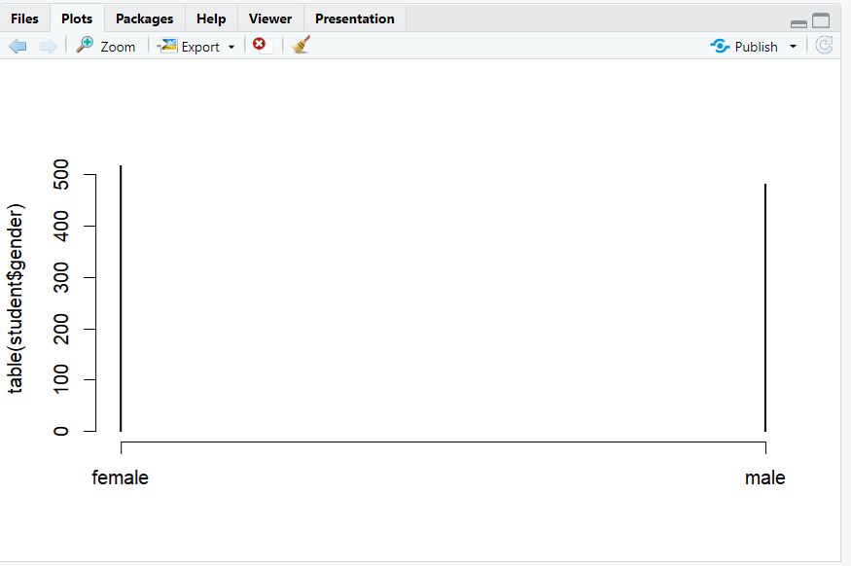
table(student$gender)

#Graph to know count of students and their scores using GGPLOT

ggplot(student, aes(x=math_score)) +
geom_freqpoly(binwidth=1,size=1)

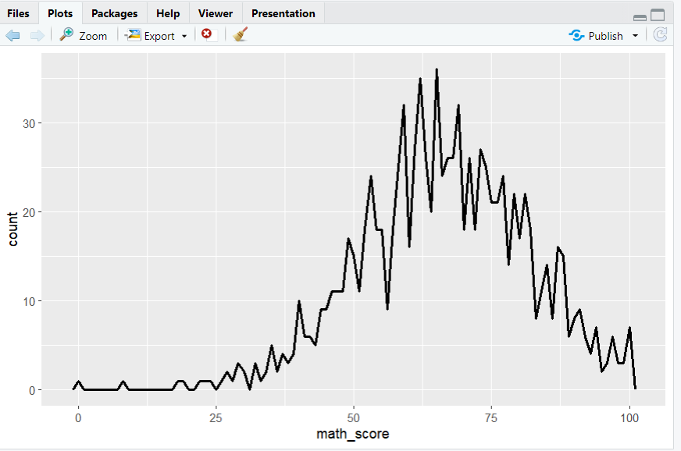

ggplot(student, aes(x=reading_score)) +
geom_freqpoly(binwidth=1.5,size=1.5)

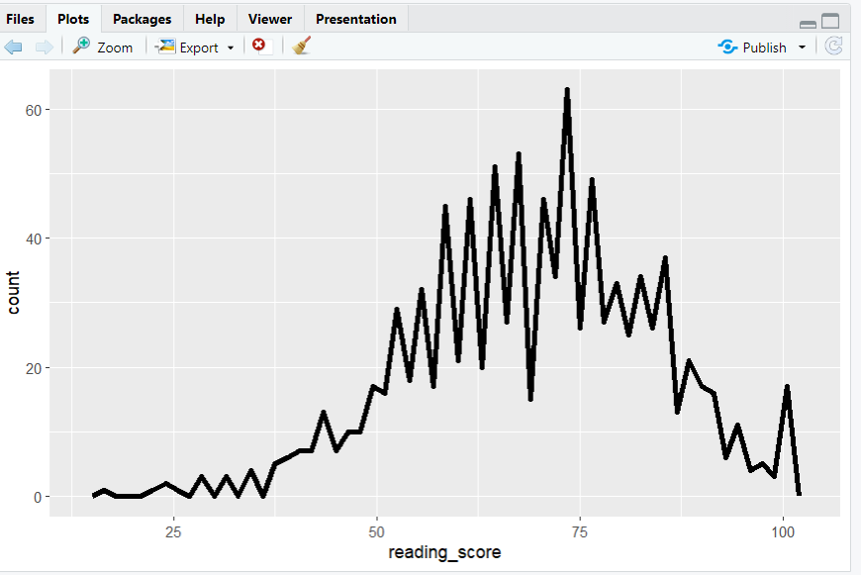
ggplot(student, aes(x=writing_score)) +
geom_freqpoly(binwidth=1,size=1)

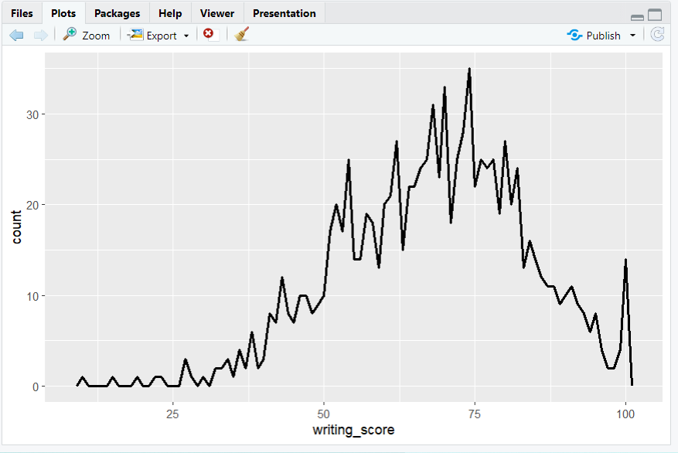
#boxplot
p1_box=ggplot(student, mapping=aes(x=math_score, y=gender))+geom_boxplot()

p1_box

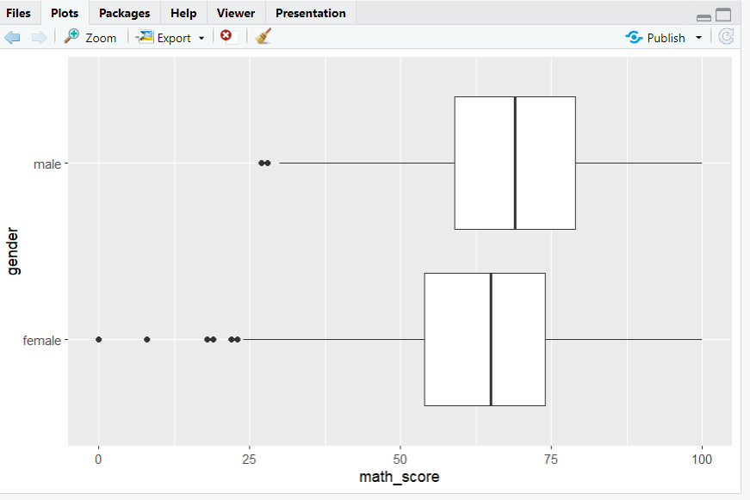

p2_box=ggplot(student, mapping=aes(x=reading_score, y=group))+geom_boxplot()
p2_box

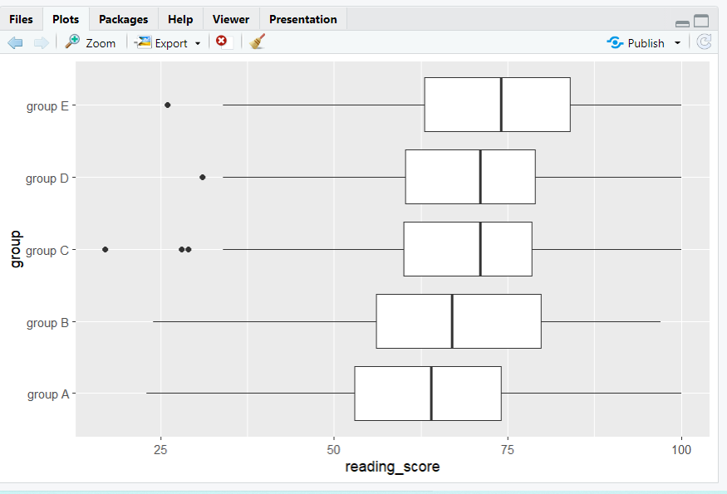
#no of students by their group who's score is more than 40 in maths and so on.
#Geombar
x2= student %>%
group_by(group) %>%
select(math_score,reading_score,writing_score) %>%
filter(math_score>40)
x2 %>% ggplot() + geom_bar(aes(x2$group,fill = x2$group))

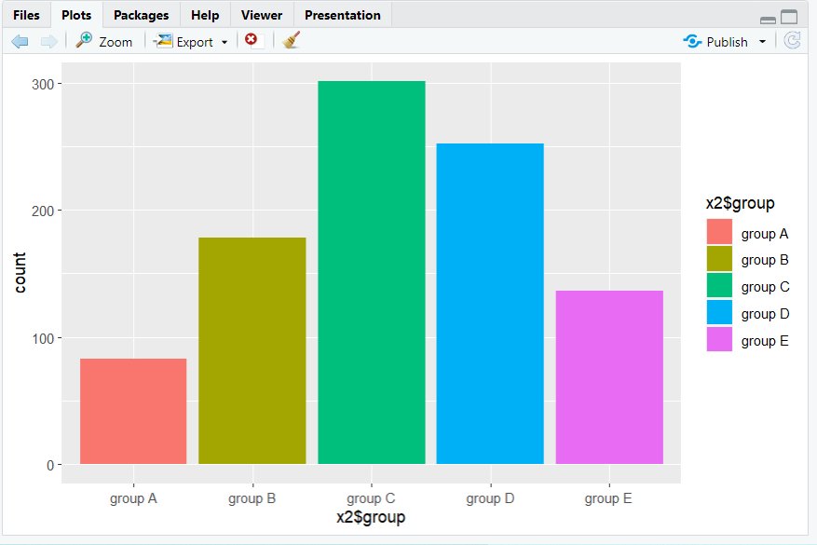

x1= student %>%
group_by(gender) %>%
select(math_score,reading_score,writing_score) %>%
filter(math_score > 40)
x1 %>% ggplot() + geom_bar(aes(x1$gender,fill = x1$gender))

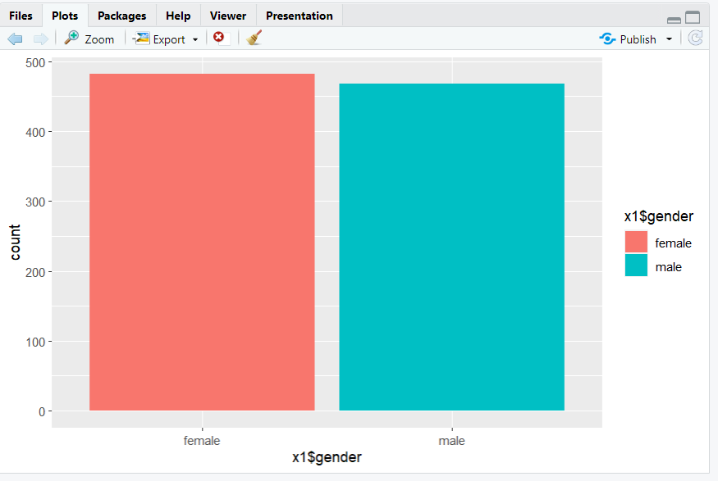
x3= student %>%
group_by(math_score) %>%
select(math_score,reading_score,writing_score) %>%
filter(writing_score>50)
x3 %>% ggplot() + geom_bar(aes(x3$math_score,fill = x3$math_score))

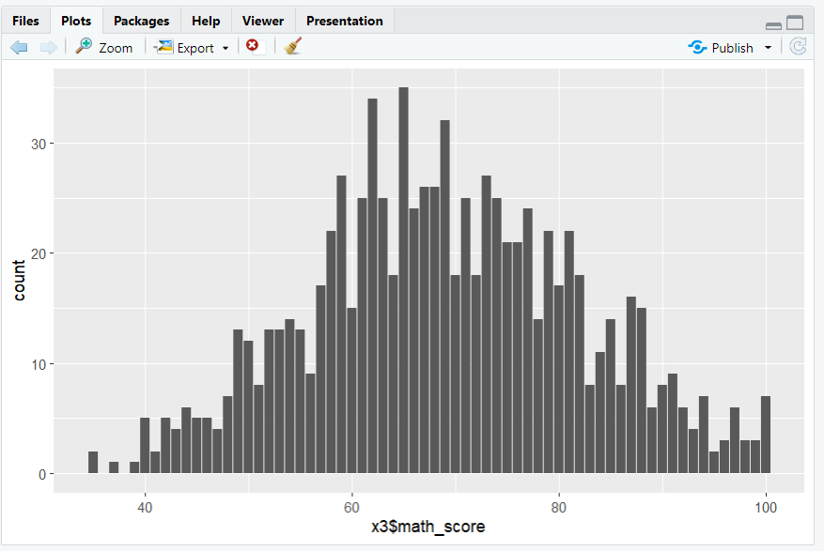
#a new column for total marks

new_marks = mutate(student,total_marks = round(math_score+reading_score+writing_score))
new_marks$total_marks
new= table(new_marks$total_marks)
cbind(new)

